Unit 3
Data cleaning using python: Overview of data cleaning, Steps Involved in Data Cleaning: Data inspection and exploration, Handling missing data, Handling outliers, Data transformation, Advantages & disadvantages of Data Cleaning.

Data Preprocessing

· It refers to the techniques and procedures used to prepare raw data into a clean, organized, and structured format suitable for analysis or modeling.

. Improving Data Quality
· Enhancing Model Performance
· Reducing Computational Complexity Ensuring Compatibility

Overview of data cleaning
Data cleaning is the process of identifying and correcting errors, inconsistencies, and missing values in a dataset to improve data quality before analysis or machine learning.
Raw data often contains:
- Missing values
- Duplicate records
- Incorrect data types
- Outliers
- Inconsistent formatting
- Invalid or incorrect entries
Python provides powerful libraries like Pandas, NumPy, and OpenPyXL to clean data efficiently.

Example:
import pandas as pd
data = pd.read_csv("data.csv")
print(data.head())

This loads the dataset for cleaning.

1) Missing Values
Missing values occur when some data fields are empty or not recorded.
Example
Name | Age | Salary
Amit | 25 | 30000
Ravi | NaN | 25000
Here, Ravi’s age is missing.
Why it happens:
- Data entry mistakes
- Information not available
- System errors

How to handle:
- Remove rows/columns with missing values
- Fill with mean, median, mode, or default values

df.dropna()
df.fillna(df.mean())

2) Duplicate Records
Duplicate records are repeated entries in the dataset.
Example:
ID | Name
1 | Rahul
1 | Rahul

Same record appears twice.
Problems caused:
- Incorrect analysis results
- Increased dataset size unnecessarily
How to handle:
Remove duplicates.

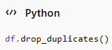
3) Incorrect Data Types
When data is stored in the wrong format.
Example:
Age should be integer but stored as text.
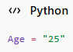
Instead of:
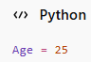
Problems caused:
- Calculation errors
- Difficulty in analysis
How to handle:
Convert datatype.
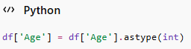
4) Outliers
Outliers are values that are very different from other values.
Example:
Salary
25000
30000
500000
500000 may be an outlier.
Problems caused:
- Distorts averages
- Affects machine learning models
How to handle:
- Remove outliers
- Use IQR or Z-score methods

5) Inconsistent Formatting
Data values are written in different formats.
Example:
- Nagpur
- nagpur
- NAGPUR
All represent the same city.
Problems caused:
- Incorrect grouping/counting
How to handle:
Standardize formatting.
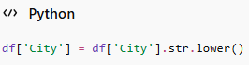
6) Invalid or Incorrect Entries
These are wrong values entered in the dataset.
Example:
Age
-5
200
These values are invalid.
Another example:
- Gender = "Unknown123"
Problems caused:
- Incorrect analysis
- Poor data quality
How to handle:
- Validate entries
- Replace or remove incorrect values
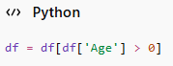

Steps Involved in Data Cleaning

1. Import the Dataset
Load the dataset into Python.
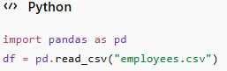

2. Understand the Data
Check structure, columns, and data types.
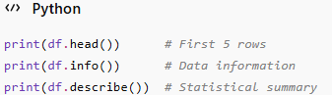

3. Handle Missing Values
Find and manage null values.
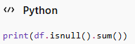
Methods:
- Remove missing values:
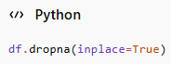
Fill missing values:
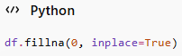
4. Remove Duplicate Data
Check and remove repeated rows.
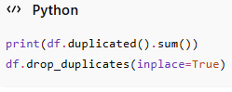
5. Correct Data Types
Convert columns to proper data types.
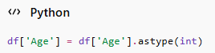
6. Rename Column Names
Make column names clear and consistent.
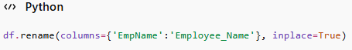
7. Handle Outliers
Detect unusual values.
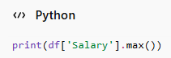
You can remove outliers using statistical methods like:
- IQR method
- Z-score method

8. Fix Inconsistent Formatting

Standardize text values.

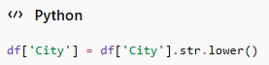
Example:
- Nagpur
- nagpur
- NAGPUR
All become:
- nagpur

9. Remove Unnecessary Columns
Delete irrelevant columns.
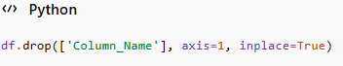

10. Save the Cleaned Data
Store the cleaned dataset.

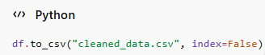

Data Inspection in Data Science Using Python

Introduction
Data inspection is the process of examining a dataset to understand its structure, quality, and contents before analysis or machine learning. It helps identify:
- Missing values
- Duplicate records
- Incorrect data types
- Outliers
- Data distribution
In Python, data inspection is commonly performed using the Pandas library.

Steps of Data Inspection Using Python

1. Import Required Library
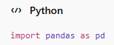
2. Load the Dataset
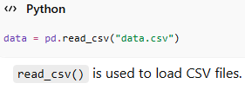
3. Display First Records
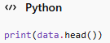
Purpose:
- Displays the first 5 rows of the dataset.
4. Display Last Records
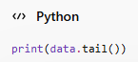
Purpose:
- Displays the last 5 rows.
5. Check Dataset Shape
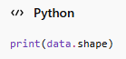
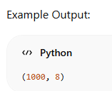
Meaning:
- 1000 rows and 8 columns.

6. Display Column Names
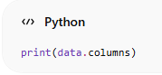
Purpose:
- Shows all column names.
7. Check Data Types
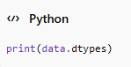
Purpose:

Identifies integer, float, string, etc.
8. Dataset Information
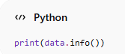
Displays:
- Total entries
- Non-null values
- Data types
- Memory usage
9. Statistical Summary
print(data.describe())
Provides:
- Mean
- Standard deviation
- Minimum value
- Maximum value
- Quartiles

10. Check Missing Values
print(data.isnull().sum())
Purpose:
- Counts missing values in each column.

11. Check Duplicate Records
print(data.duplicated().sum())
Purpose:
- Finds duplicate rows.

12. Check Unique Values
print(data["Department"].unique())
Purpose:
- Displays unique categories.

Example Program
import pandas as pd
# Load dataset
data = pd.read_csv("students.csv")
# Display dataset
print(data.head())
# Shape of dataset
print("Shape:", data.shape)
# Dataset information
print(data.info())
# Statistical summary
print(data.describe())
# Missing values
print(data.isnull().sum())
# Duplicate rows
print("Duplicates:", data.duplicated().sum())

Advantages of Data Inspection
- Helps understand dataset structure
- Detects missing and incorrect values
- Improves data quality
- Supports data cleaning
- Improves analysis and model accuracy

Data Exploration in Data Science Using Python
Introduction
Data exploration is the process of analyzing and understanding datasets to discover patterns, trends, relationships, and anomalies. It is an important step in data science before building machine learning models.
Using Python and libraries like Pandas and Matplotlib, data exploration becomes easier and more effective.

Objectives of Data Exploration
- Understand dataset structure
- Identify trends and patterns
- Detect missing values and outliers
- Analyze relationships between variables
- Prepare data for modeling

Import Required Libraries
import pandas as pd
import matplotlib.pyplot as plt

Load Dataset
data = pd.read_csv("students.csv")

Display Dataset
First 5 Rows
print(data.head())
Last 5 Rows
print(data.tail())

Statistical Summary
print(data.describe())
This provides:
- Mean
- Median
- Standard deviation
- Minimum value
- Maximum value

Check Missing Values
print(data.isnull().sum())

Explore Unique Values
print(data["Department"].unique())

Frequency Count
print(data["Department"].value_counts())
Purpose:
- Counts occurrences of each category.

Correlation Between Variables
print(data.corr())
Purpose:
- Shows relationships between numerical variables.

Grouping Data
print(data.groupby("Department")["Marks"].mean())
Purpose:
- Calculates average marks department-wise.

Data Visualization
Visualization helps understand data patterns easily.

Histogram
data["Marks"].hist()
plt.show()
Purpose:
- Displays distribution of marks.

Bar Chart
data["Department"].value_counts().plot(kind="bar")
plt.show()
Purpose:
- Shows category frequencies.

Scatter Plot
plt.scatter(data["Age"], data["Marks"])
plt.xlabel("Age")
plt.ylabel("Marks")
plt.show()
Purpose:
- Displays relationship between age and marks.

Example Program
import pandas as pd
import matplotlib.pyplot as plt
# Load dataset
data = pd.read_csv("students.csv")
# Explore dataset
print(data.head())
print(data.describe())
# Missing values
print(data.isnull().sum())
# Frequency count
print(data["Department"].value_counts())
# Histogram
data["Marks"].hist()
plt.show()

Advantages of Data Exploration
- Helps understand data patterns
- Detects anomalies and outliers
- Improves data quality
- Supports decision making
- Enhances machine learning model performance

